
Feed Acidifier based on five fermented feedstuffs and emulsified fat ---Five Acid Peptide

Feed Acidifier must be “Tastable Acid, Effective Acid”, should be small proportion feed raw material. Five Acid Peptide(ie:FAP) is an organic acid acidifier using corn, rice, soybean meal, grease, fish meal / corn protein powder, utilizing self-breeding ultra-high sugar-resistant, acid-resistant, permeation-resistant, acid-producing strains, adopting national invention patent advanced technology.
- Rich in Citric Acid, Lactic Acid, Acetic Acid, Propanoic Acid, Butyric Acid, Emulsified Fat, active small peptide (including antibacterial peptide), high sweet Oligose, Yeast Protein, Probiotics, Biological Enzyme, Vitamin, Organic Acid Calcium and the unnamed growth factor.
- A kind of etching-coated type compound organic acid acidifier combined acidifier with enzymatic hydrolysis fermentation feed and emulsified fat, the later two of which are as carrier, perfectly realize the mutual improvement among them. Different from the mixed feed acidifier in effective component, cost-performance and actual feeding effect.

Compounded organic acid, mutual improvement, effective anti-diarrhea
Organic acids on the functional compound of active small peptides, high sweet oligose, probiotics, mutual improvement, making up for the lack of gastric acid, acidification of the gastrointestinal tract, restraining harmful bacteria, good effect of antibacteria and prevention and treatment of diarrhea, decreasing diarrhea rate above 80%, poultry enterovirus syndrome cure rate up to 90% or more.

Acid smells delicious, feed intake increasing
Five feedstuffs rich in active small peptide, high sweet obligose, abundant organic acid and emulsified fat, acid smells delicious, aromatic character and agreeable taste, good feeding attraction, feed intake increased up to 8%.

Less stimulus and damage
Organic acid etching and infiltrating during the process of enzymolysis and fermentation, natural coated, no stimulation and damage to the oral cavity and esophagus, same to gastrointestinal mucosa, sustained equilibrium releasing, most can enter the back of the intestine.
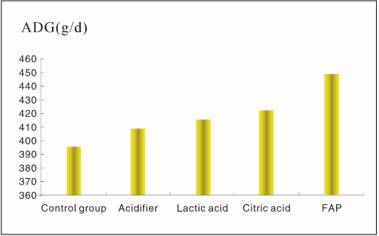
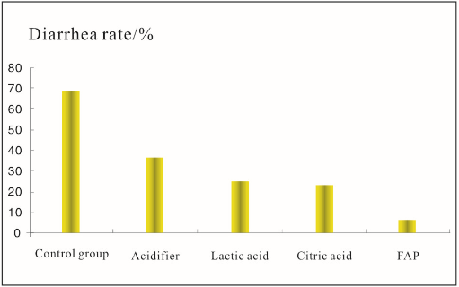
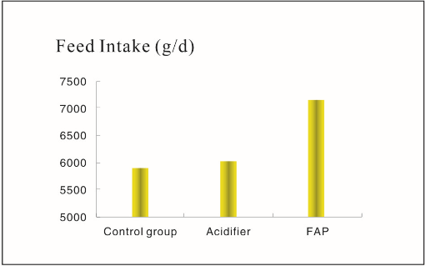
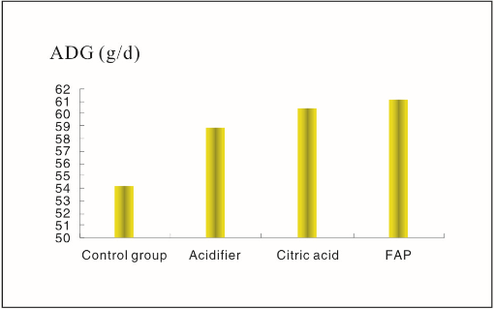
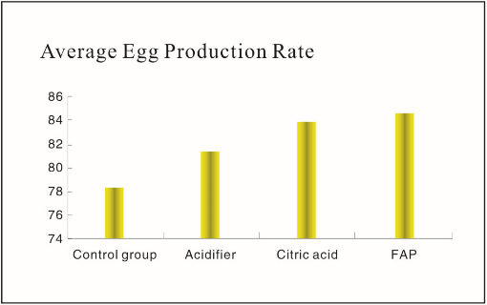
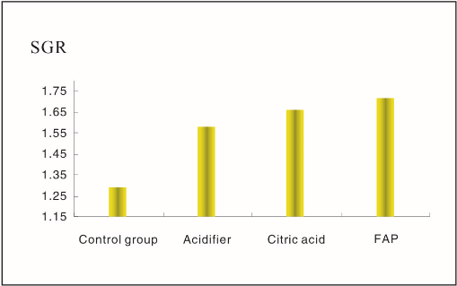
Form 1 The effections of FAP on ADG of piglet
Form 2 The effections of FAP on Diarrhea rate of piglet
Form 3 The effections of FAP on ADFI of milking sow
Form 5 The effections of FAP on 37th week AEPR
of laying hen
Form 4 The effections of FAP on ADG of chicken
Form 6 The effections of FAP on SGR of Tilapia

【Quality standard】
Form 7 Main nutritional ingredients of FAP
Item | Index | Item | Index | Item | Index
Moisture/% | ≤10.0 | Crude protein/% | ≥10.0 | Soluble carbohydrate/% | ≥0.50
Total acid (in the case of lactic acid)/% | ≥60.0 | Small peptides and dissociated Amino acids/% | ≥0.25 | Lysine/% | ≥0.21
Citric acid/% | ≥35.0 | Crude fat/% | ≥3.0 | Methionine/% | ≥0.15
Lactic acid/% | ≥5.0 | Crude fiber/% | ≤8.0 | Threonine/% | ≥0.19
Acetic acid/% | ≥2.0 | Crude ash/% | ≤12.0 | Tryptophan/% | ≥0.06
Propanoic acid/% | ≥1.0 | Calcium/% | ≤3.0 | Total probiotics cfu/g | ≥0.1×10⁴
Butyric acid/% | ≥1.0 | Total phosphorus/% | ≤3.0 | Small molecular nutrition content/% | ≥40.0

Its total acid is same as some of the mixed feed acidifier in the market. But differences are all contained acid are organic acid, enzymatic hydrolysis fermentation feed and emulsified fat set as carrier, and the coating is natural etching-coated.

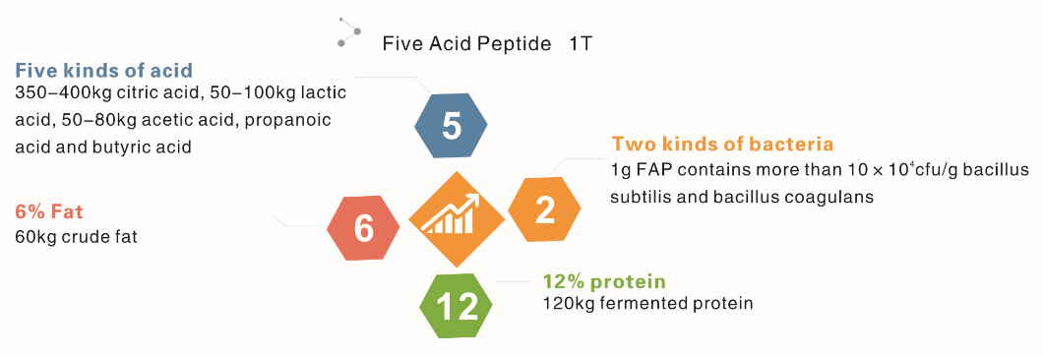

【Physicochemical property】
- Smell and taste test: smells good, taste sweet, most of the nutrients are melt in your mouth, sweet and sour, it has the taste of sweet potato and fermentation.
- Solubility test: More than 50% of the nutrients can be dissolved into water, nutritious are soluble organic acid, rich in active small peptide, high sweet oligose and probiotics.
- Usage: Anthony pig creep feed: 15-30 kg/ton; Piglet conservation feed: 10-20 kg/ton;
Milking sow feed: 5-10 kg/ton; Calf & Goat feed: 10-20 kg/ton;
Chicken and Duck feed: 5-10 kg/ton; Aquatic animal feed: 10-20 kg/ton

FISUGARPEPTIDE BIOLOGY

【About Us】

Fisugarpeptide Biology Engineering Co., LTD is a National High-tech Enterprise, professionally engaged in R & D and production of high-grade feed biological materials, with about 300 existing staffs, total assets of 519 million RMB, three biological fermentation bases built in cities of Chaohu, Luan and Hefei, and mainly produce biological pre-digestion products. It is one of famous Chinese developer and supplier of high-grade feed biological material.

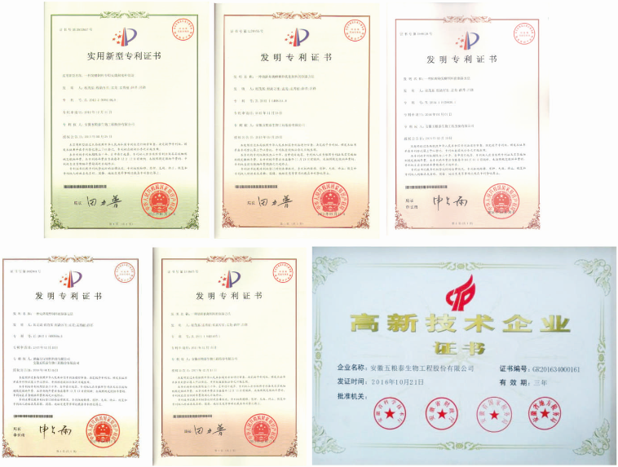

Lu’an fermentation base is located in Lu’an State-level Economic-technological Development Zone, covers an area of 50 acres, with 5000㎡ office building, 1800㎡ science and technology building, 29000㎡ production workshop, total investment of more than 90 million RMB, including fermentation equipment investment valued more than 50 million RMB.
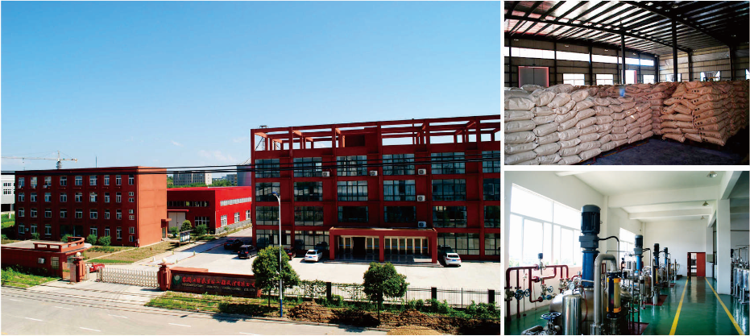

Lu’an Fermentation Base
Chaohu fermentation base is located in Chaohu Juchao Economic-technological Development Zone, covers an area of 150 acres, with 6000㎡office building, 3000㎡science and technology building, 85000㎡ production workshop, total investment of 280 million RMB, including fermentation equipment valued 180 million RMB.
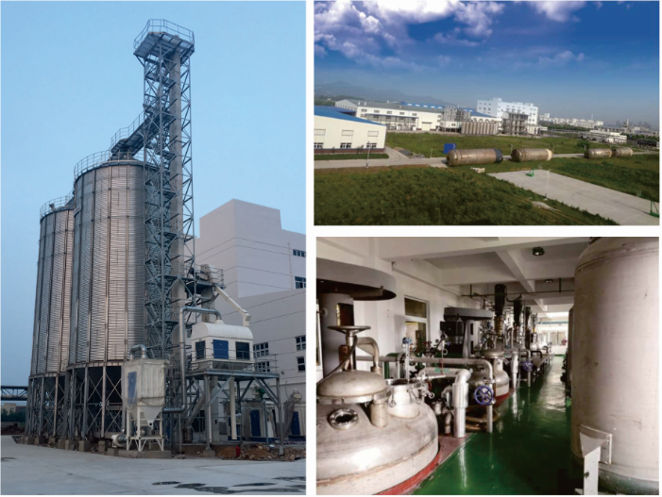
Chaohu Fermentation Base

We also pay much attention on Production and Research Cooperation. It is a big chance and bright future for us to have cooperated with Academician Yin Yulong, Chinese Academy of Engineering on building academician workstation.

We will base on feed ingredients, designed for biological fermentation and emulsion, introduce the new technology and new products of human nutrition to animal nutrition, develop to be a safe, economic and efficient forerunner of biological feed ingredients.

FISUGARPEPTIDE BIOLOGY ENGINEERING CO., LTD
Add：No.8 Hengshan Road, Luan Eoconomic and Technological Development Zone, Anhui Province, China
Tel：+86-564-3719129 Fax：+86-564-3719127
E-mail：Fisugarpeptide@sohu.com P.C：237000
http://www.fisugarspeptide.com

